Remember, intentionality when it comes to Creating a Classroom Culture
Cultures begin with and are maintained by leaders. Leaders should lead with their why’s.
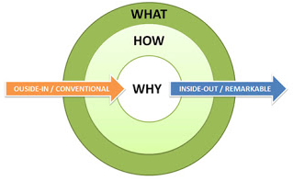
Why do we need communication?
Why do we need collaboration?
Why do we need consistency?

Communicate your why. Communicate your vision.
What is your vision of a well-structured classroom and the roles everyone plays?
(Group visions developed through discussion work best.)

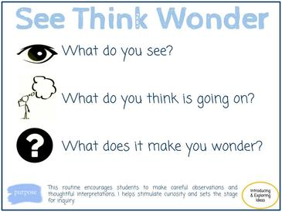
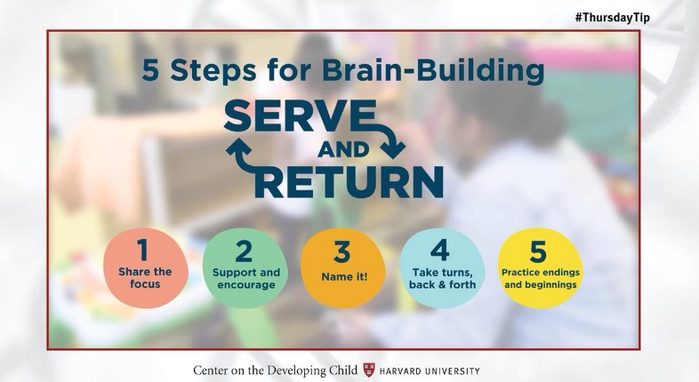
When belongingness is felt, there is an increase in learning and engagement. Build belongingness through relationships, goals, displays, and traditions.
Strategies to Build Relationships
Conversations and Comments
Play
Games
Group Work
Co-Existing Relationships

What social-emotional goals do you have for the class?
What do you hope for the children to learn social-emotionally wise?
Expectations for children should be short and clear.
Provide children with strategies to problem-solve.
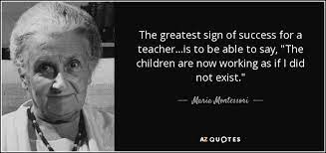
Encourage children to support one another.

Displays to support sense of belonging and community

Portraits | Exp/Doc Boards | Children’s Workings | Calendars & Schedules
    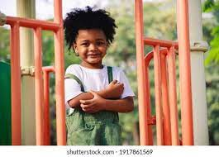      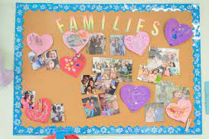 | 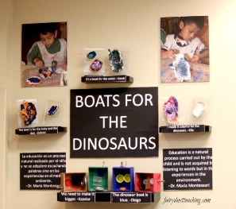  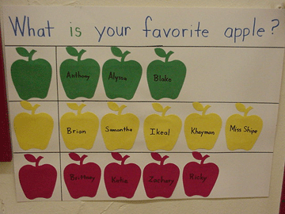  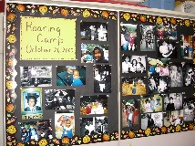 | Gifted Art  Accomplished Art  Group Projects  Photos of children in play centers | Monthly Visual calendar  Daily Visual Schedule  Visual routines

Traditions to support sense of community and support
Routines | Jobs | Events
Consistent Daily Routines and Schedules  Group “Mantras”  - Morning Songs  - Rituals (Today for lunch..) | Opportunities to help manage the classroom. | Birthdays  Cultural  Family Engagement  Field Trips

Language has the ability to shape thoughts and behaviors. Language in the classroom should be used to shape culture and thinking patterns.

